How to use the audio data collection system:
- Make sure the two boards are properly connected (see board images below for pin designations)
- Configure the microphone board shorting blocks for automatic or manual gain (see board images below for patterns)
- Give power to the board (see board images below for where Vdd and GND pins are)
- Power LED will turn on
- Record LED will turn on and then off
-----------------
- If you want to change the gain mode/values or the sync timer interval
  - Use the PICKit3 to Program the processor with the correct CVR and CVRR values for the desired gain and gain mode (see table below) as well as the sync time
    - The values are at the top of the “main_full_system_final.c” file in the #define section as CVRval and CVRRval
    - The sync timer value is #defined as syncCounts. Every value of syncCounts corresponds to 10ms of time (e.g. syncCounts=300 is a 3 second sync time).
-----------------
- Put microSD in the card slot on the board (you may also do this before you give the board power if you want)
- Board is now ready to record
- Press record button
  - Record LED will turn on
  - Data is being recorded to microSD card in the form of unsigned 16-bit integers
- Press record button
  - Record LED turns off, then flashes twice
- Data is done writing and file is ready for viewing
-----------------
- You may now remove the microSD (it doesn’t matter if the board has power when you remove the card)
OR
- You can press the record button again to create a new data file and begin writing to it
-----------------
- You may power off the board whenever the device is not actively recording

When microSD card is in the PC:
- Copy the desired file to the folder where the “readSoundData.m” file is located
- Open “readSoundData.m”
- Change the variables at the top of the file “readSoundData.m” to read the desired data file and name the outputted *.wav file
- If you don’t want to make/edit the *.wav file, change “makeWavFile” to equal 0
- If you don’t want MATLAB to output the graphical waveform and fast Fourier transform, change “makePlots” to equal 0
- Run the MATLAB script
- You now have a *.wav file of the data
- The sample numbers where the sync markers were made are in the “markerPoints” variable
- The raw and corrected data as well as voltage and -1 to +1 normalized data arrays are written into column vectors

 | CVRR=0 |  |  | CVRR=1
CVR<3:0> | Voltage (V) | Gain (dB) |  | Voltage (V) | Gain(dB)
0 | 0.83 | 21.6 |  | 0
1 | 0.93 | 13.6 |  | 0.14 | 76.8
2 | 1.03 | 5.6 |  | 0.28 | 65.6
3 | 1.13 |  |  | 0.41 | 55.2
4 | 1.24 |  |  | 0.55 | 44
5 | 1.34 |  |  | 0.69 | 32.8
6 | 1.44 |  |  | 0.83 | 21.6
7 | 1.55 |  |  | 0.96 | 11.2
8 | 1.65 |  |  | 1.1 | 0
9 | 1.75 |  |  | 1.24
10 | 1.86 | ACG Mode |  | 1.38
11 | 1.96 |  |  | 1.51
12 | 2.06 |  |  | 1.65
13 | 2.17 |  |  | 1.79
14 | 2.27 |  |  | 1.93
15 | 2.37 |  |  | 2.06

*Don’t use the highlighted cell values
Table 1. Voltage Reference Values and Associated Gains
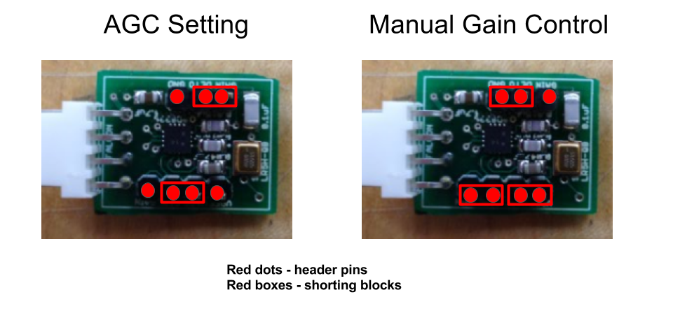
Figure 1. Gain Control Settings
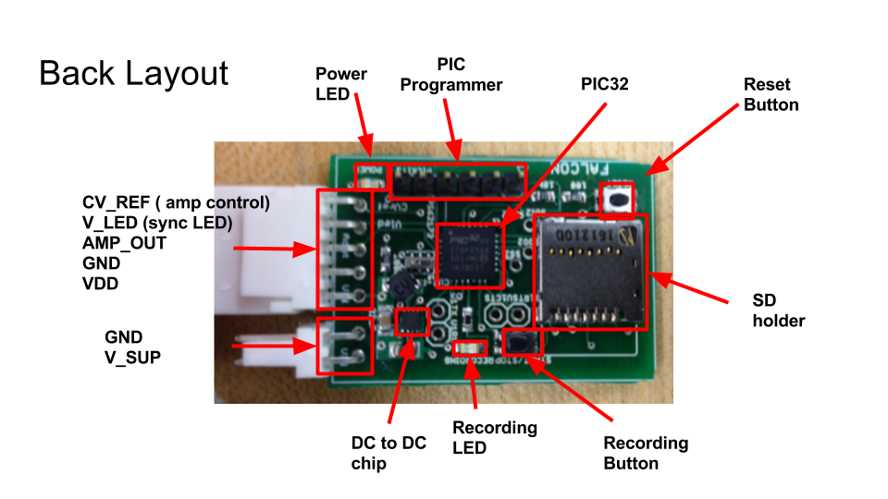
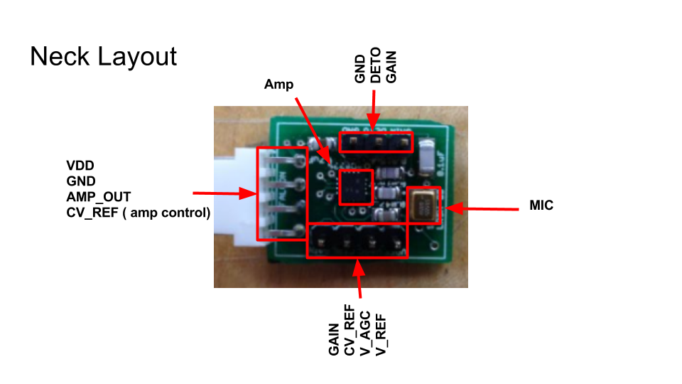
Figure 2. Back Board Layout

Figure 3. Neck Board Layout

